CHOMAVISION Outtakes
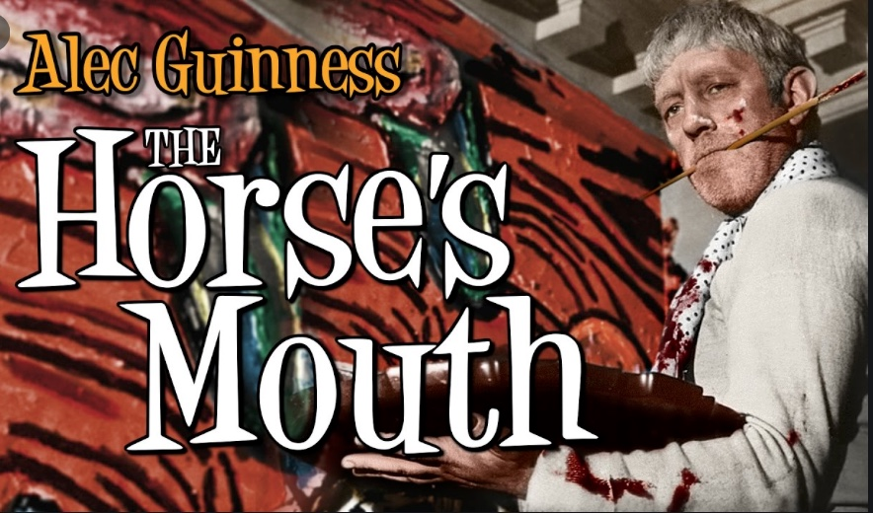
For Bob’s 81st Birthday and Movie Monday’s 12th Anniversary I screened The Horse’s Mouth. It’s a fictional film about a elderly artist, the incorrigible Gully Gimson played by Alec Guiness, whose spirit is so much like Bob’s.
It was a nice match-up. We displayed some of Bob’s artwork, old and new at this event.
I wheeled the one surviving sculpture a quarter mile from my basement to the theatre.
It was fun to again bring Bob’s work and sparky personality to an audience.
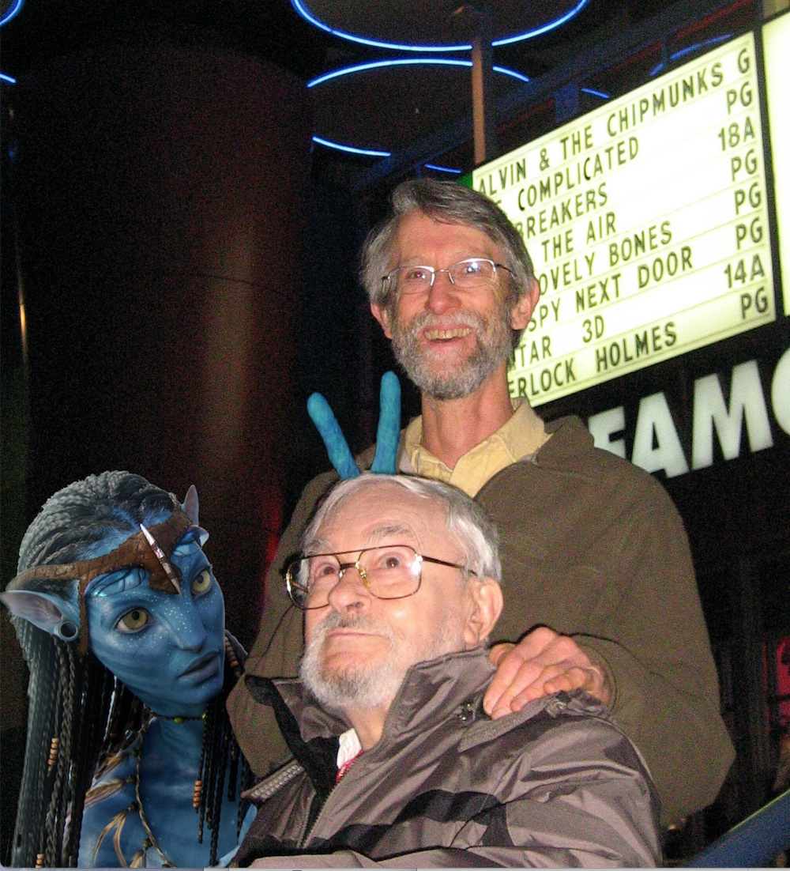
AVATAR
I was surprised when Bob told me he hadn’t been to a movie theatre in 30 years. One of my favorite outings with him was when I invited him to see Avatar. Right up front, 3D glasses on, smiling all the way. This is the kind of stuff he’d been dreaming up himself all these years, come to life, leaping off the screen!

BIPOLAR BRAIN
A segment I really wanted in the film right at the end where Bob states the essence of the piece:
Bruce “In this last interview I did with Bob, he nailed, in his way, the essence of getting in the creativity groove; when a sparky bipolar brain like his latches onto something and attempts to solve it, to create something new.”

Bob:
“…. and your interest starts to widen into all kinds of fields…, And you become interested in, not one thing but many things, and it’s hard for you to concentrate because of all the things that bother you at one time…
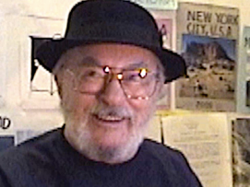
But if you do concentrate I think you sort of have the power, that nothing else bothers you except the thing you are concentrating on.”

Bruce “And it’s been pretty satisfying in your life?”

Bob “You’re Damn Right!”

